

**Polling District and Polling Place Review 2025**

**Elswick Ward**

**Parliamentary Constituency:** Central and West

**(Proposed) Polling Districts:** I01, I02, I03, I04, I05

The Local Government Boundary Commission for England are an independent body accountable to Parliament. They are responsible for reviewing councils to make sure their patterns of internal wards are fair and sensible. Their reviews include at least two rounds of public consultation before they make recommendations for change.

The final recommendations were published on 7 January 2025, and the new arrangements apply to local elections from 2026.

As a result of changes to ward boundaries the Acting Returning Officer (ARO) is conducting a review of polling districts and polling places to ensure that they are suitable for the new ward boundaries.

For more information on the local government boundary review visit: <https://www.lgbce.org.uk/all-reviews/newcastle-upon-tyne>

This document provides details of the review, along with the initial recommendations and comments of the Acting Returning Officer (ARO). Also, the election rules require the ARO to decide how many polling stations are required for each polling station and the ARO must allocate electors to the polling stations in such manner as they think most convenient.

These recommendations will be open to all residents, stakeholders, and any interested parties. We shall be seeking representations from local disability groups on the accessibility and suitability of polling places. Any comments should be addressed in the first instance to pollingplaces@newcastle.gov.uk where they will be collated on behalf of the (Acting) Returning Officer.

We considered the following factors:

* **Identifying new polling places:** We will look for new polling places in areas where the existing provision is unsuitable or unavailable.
* **Feedback:** We will consider feedback received following recent elections, consultation from members of the public, elected members, and other stakeholders.
* **Accessibility:** We will try to ensure that every polling place is accessible to electors with disabilities.
* **Facilities**: We will make sure that all electors have such reasonable facilities for voting as are practicable in the circumstances.
* **Elector numbers:** We will try to comply with the Electoral Commission guidance on the maximum number of electors that should be allocated to a polling station which should not exceed 2,250.
* **Future housing developments**: We will consider the impact of proposed housing developments on polling station electorates.

**(Current) Elswick Ward**

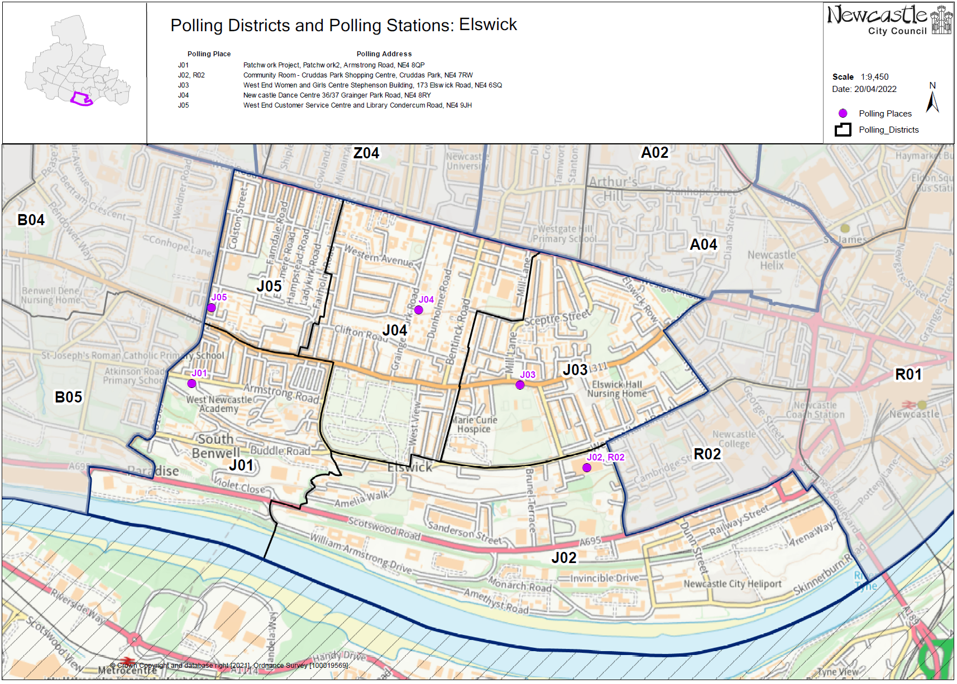This map shows the current ward and polling district boundaries and the polling places.

**(New)**

**Elswick Ward**

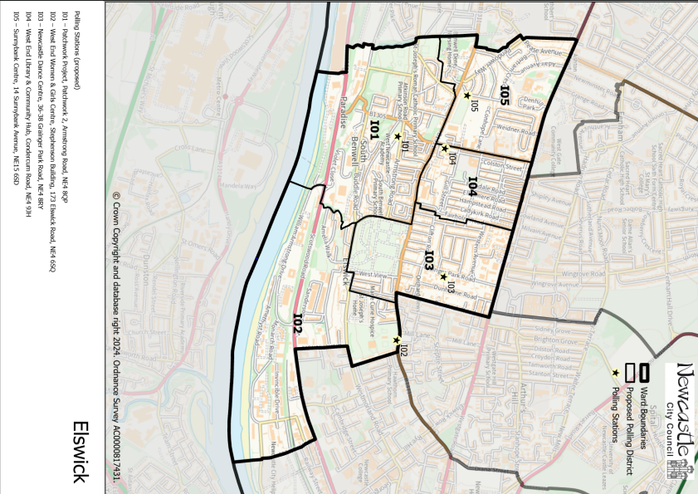

This map shows the new ward and the proposed polling districts and the proposed polling places.

* **I01** – Patchwork Project, Patchwork 2, Armstrong Road, NE4 8QP
* **I02** – West End Women & Girls Centre, Stephenson Building, 173 Elswick Road, NE4 6SQ
* **I03** – Newcastle Dance Centre, 36-38 Grainger Park Road, NE4 8RY
* **I04** – West End Library & Community Hub, Condercum Road, NE4 9JH
* **I05** – Sunnybank Centre, 14 Sunnybank Avenue, NE15 6SD

**Elswick Ward**

**Polling District I01**

|  |  |
| --- | --- |
| **Current Polling District** | **Current Polling Place** |
| B05 (part of)  J01 (full) | Carnegie Building, Atkinson Road, NE4 8XS  Patchwork Project, Patchwork 2, Armstrong Road, NE4 8QP |

|  |  |  |
| --- | --- | --- |
| **Proposed Polling District** | **Predicted**  **Polling Station Electorate** | **Proposed Polling Place** |
| I01 | 1279 | Patchwork Project, Patchwork 2, Armstrong Road, NE4 8QP |
|  | | |

|  |
| --- |
| **Considerations and Proposals** |
| Merge current J01 and part of current B05 to create the proposed I01 district. Properties to the west of Atkinson Road and continuing west to Hodgkin Park, will be incorporated in the proposed I01 polling district.  Both stations are within the proposed I01 district so both could be considered, however the proposal is to use Patchwork Project. |
|  |

|  |
| --- |
| **Preliminary Consultation – Elected Members comments and feedback** |
| No comments received. |

**Elswick Ward**

**Polling District I02**

|  |  |
| --- | --- |
| **Current Polling District** | **Current Polling Place** |
| J02 (part of)  J03 (part of) | Community Room Cruddas Park Shopping Centre, Cruddas Park, NE4 7RW  West End Women and Girls Centre, Stephenson Building, 173 Elswick Road, NE4 6SQ |

|  |  |  |
| --- | --- | --- |
| **Proposed Polling District** | **Predicted**  **Polling Station Electorate** | **Proposed Polling Place** |
| I02 | 322 | West End Women and Girls Centre, Stephenson Building, 173 Elswick Road, NE4 6SQ |
|  | | |

|  |
| --- |
| **Considerations and Proposals** |
| Merge part of current J02 and part of current J03 to create the proposed I02 district. The proposed district incorporates properties north of Westmorland Road, continuing up to Elswick Road.  West End Women and Girls Centre is the suggested polling station for the proposed I02 district.  West End Women and Girls is suggested as a double polling station for the proposed I02 and A04 districts. |
|  |

|  |
| --- |
| **Preliminary Consultation – Elected Members comments and feedback** |
| No comments received. |

**Elswick Ward**

**Polling District I03**

|  |  |
| --- | --- |
| **Current Polling District** | **Current Polling Place** |
| J04 (full) | Newcastle Dance Centre, 36-38 Grainger Park Road, NE4 8RY |

|  |  |  |
| --- | --- | --- |
| **Proposed Polling District** | **Predicted**  **Polling Station Electorate** | **Proposed Polling Place** |
| I03 | 1391 | Newcastle Dance Centre, 36-38 Grainger Park Road, NE4 8RY |
|  | | |

|  |
| --- |
| **Considerations and Proposals** |
| Current J04 now forms proposed I03.  Loses a small part of the district to Arthur’s Hill ward, east of Bentinck Road.  No change to the polling place. |
|  |

|  |
| --- |
| **Preliminary Consultation – Elected Members comments and feedback** |
| No comments received. |

**Elswick Ward**

**Polling District I04**

|  |  |
| --- | --- |
| **Current Polling District** | **Current Polling Place** |
| J05 (full) | West End Library and Community Hub, Condercum Road, NE4 9JH |

|  |  |  |
| --- | --- | --- |
| **Proposed Polling District** | **Predicted**  **Polling Station Electorate** | **Proposed Polling Place** |
| I04 | 1385 | West End Library and Community Hub, Condercum Road, NE4 9JH |
|  | | |

|  |
| --- |
| **Considerations and Proposals** |
| Current J05 is now the proposed I04. No change to the polling district boundary.  No change to the polling place. |
|  |

|  |
| --- |
| **Preliminary Consultation – Elected Members comments and feedback** |
| No comments received. |

**Elswick Ward**

**Polling District I05**

|  |  |
| --- | --- |
| **Current Polling District** | **Current Polling Place** |
| B04 (part of) | Sunnybank Centre, 14 Sunnybank Avenue, NE15 6SD |

|  |  |  |
| --- | --- | --- |
| **Proposed Polling District** | **Predicted**  **Polling Station Electorate** | **Proposed Polling Place** |
| I05 | 900 | Sunnybank Centre, 14 Sunnybank Avenue, NE15 6SD |

|  |
| --- |
| **Considerations and Proposals** |
| Part of the current B04 district now forms the proposed I05 district. The proposed district continues as far west to Fox and Hounds Lane.  No change to the polling place. |

|  |
| --- |
| **Preliminary Consultation – Elected Members comments and feedback** |
| No comments received. |